|  |  |
| --- | --- |
|  | **Using noninvasive genetics to compare how a California freeway affects gene flow in a disturbance-averse versus a disturbance-tolerant species** |
| April 2017 | A Research Report from the National Center for Sustainable Transportation |
|  | Amanda Coen, University of California, Davis  Andrea Schreier, University of California, Davis |





**About the National Center for Sustainable Transportation**

The National Center for Sustainable Transportation is a consortium of leading universities committed to advancing an environmentally sustainable transportation system through cutting-edge research, direct policy engagement, and education of our future leaders. Consortium members include: University of California, Davis; University of California, Riverside; University of Southern California; California State University, Long Beach; Georgia Institute of Technology; and University of Vermont. More information can be found at: ncst.ucdavis.edu.

Disclaimer

The contents of this report reflect the views of the authors, who are responsible for the facts and the accuracy of the information presented herein. This document is disseminated under the sponsorship of the United States Department of Transportation’s University Transportation Centers program, in the interest of information exchange. The U.S. Government and the State of California assumes no liability for the contents or use thereof. Nor does the content necessarily reflect the official views or policies of the U.S. Government and the State of California. This report does not constitute a standard, specification, or regulation. This report does not constitute an endorsement by the California Department of Transportation (Caltrans) of any product described herein.

Acknowledgments

This study was funded by a grant from the National Center for Sustainable Transportation (NCST; Agreement No 65A0527, TO 015), supported by USDOT and Caltrans through the University Transportation Centers program. The authors would like to thank the NCST, USDOT, and Caltrans for their support of university-based research in transportation, and especially for the funding provided in support of this project. We also are grateful to Ben Sacks for the expertise provided in the course of this study. We thank the following for their technical assistance: Zac Lounsberry, Alisha Goodbla, Cate Quinn, and Ryan Peek. Additionally, we thank the dedicated interns that helped with many hours of field collection and lab work in order to produce this study.

**Using noninvasive genetics to compare how a California freeway affects gene flow in a disturbance-averse versus a disturbance-tolerant species**

A National Center for Sustainable Transportation Research Report

April 2017

**Amanda Coen,** University of California, Davis

**Andrea Schreier,** University of California, Davis

[page left intentionally blank]

TABLE OF CONTENTS

Introduction i

Materials and Methods 2

Study Highways 2

Molecular Methods 2

Data Analysis 2

Results 3

Sample Collection and Species Identification 4

Genetic Diversity 4

Genetic Connectivity 4

Discussion 6

Tables and Figures 8

References 15

Using noninvasive genetics to compare how a California freeway affects gene flow in a disturbance-averse versus a disturbance-tolerant species

EXECUTIVE SUMMARY

Roads networks may have profound impacts on the viability of wildlife populations. In particular, highways can be barriers to wildlife movement, leading to genetic diversity loss, inbreeding, and increased extinction risk for small, isolated populations on either side. The effects that highways have on wildlife movement can be variable, dependent on the unique dispersal behaviors of individual species. In this study, we test the hypothesis that highways will pose less of a barrier to coyotes, a species tolerant of human disturbance, than to gray fox, a species more sensitive to disturbance. We used landscape genetic tools to determine whether State Route 49, part of the California Essential Habitat Connectivity Project, was a barrier to coyote or gray fox movements.

Genetic diversity among both coyotes and gray foxes was high and comparable to other studies. We found little evidence of contemporary genetic structure across State Route 49 for either species. All genetic differentiation that we observed was driven by family structure and relatives were found on both sides of the highway. Coyotes exhibited a significant signal of isolation by distance and a positive association between traffic volume and genetic distance. There are two possible explanations for these findings. State Route 49 may be permeable to coyote and gray fox movement due to successful road crossings. Alternatively, State Route 49 is a barrier to coyote and gray fox movement but there may be a time lag between initial reduction of gene flow and detection of population structure.

# Introduction

Road networks have the potential to have profound impacts on the viability of wildlife populations. Highways in particular can act as barriers to wildlife movement, either through direct mortality or alteration of natural behavior patterns (Jaeger et al. 2005; Coffin 2007; Taylor and Goldingay 2010). As barriers, roads can fragment and isolate wildlife populations, increasing their risk of extinction due to demographic stochasticity, genetic diversity loss and inbreeding depression (Lande 1988; Frankham 1996; Epps et al. 2005; Holderegger and Di Giulio 2010). Maintaining connectivity across highways can reduce the threat of local extinction for fragmented populations.

The degree to which wildlife can move across roads, maintaining population connectivity, depends upon species-specific dispersal behaviors. Some taxa, such as reptiles, amphibians, and mid- to large sized mammals, are particularly impacted by roads (Fahrig and Rytwinski 2009; Benítez-López et al. 2010). Even within sensitive species there are differences in behavioral responses to roads. Disturbance tolerance is thought to be one characteristic that determines a species’ sensitivity to roads. The Trans-Canada Highway acts as a barrier for grizzly bear (*Ursus arctos*) but not for black bear (*Ursus americanus*) movement, likely because grizzly bears are more likely to avoid human activity and therefore approach roads less often (Sawaya et al. 2014). Similarly, smaller snake species more vulnerable to avian predation were more likely to avoid open habitat created by roads than larger snakes (Andrews and Gibbons 2005).

We hypothesize that the ability to maintain population connectivity across roads is related to a species’ willingness to use edge habitats, such as those alongside highways. Habitat generalists, like coyotes (*Canis latrans*) and deer (*Odocoileus spp*) may be less affected by roads than habitat specialists, such as gray foxes (*Urocyon cinereoargenteus*), which in California tend to be tied to large patches of mid-elevation scrub-lands (Neale and Sacks 2001; Riley et al. 2003; Sacks et al. 2005; Sacks et al. 2008; Farias et al. 2012). In fact, coyotes and gray foxes provide excellent models with which to test our hypothesis that freeways affect population connectivity less in disturbance-tolerant relative to disturbance-averse species. These two species have similar reproductive phenology, dispersal timing, territoriality, and diet, differing mainly in the degree of habitat specialization.

Other factors influencing the degree to which roads affect wildlife connectivity are characteristics of the roads, including width and traffic volume. Traffic volume in particular has been shown to be an important determinant of wildlife response to roads (Jaeger et al. 2005). In highways through the Canadian Rocky Mountains, including the Trans-Canada Highway, sections of low to moderate traffic were more permeable to carnivore passage than sections of high traffic (Alexander et al. 2005). Detection probabilities of two bird species, the grey shrike-thrush (*Colluricincla harmonica*) and grey fantail (*Rhipidura fuliginosa*) showed a negative correlation with traffic volume (Parris and Schneider 2008). Annual average daily traffic volumes (AADT) as low as 10,000 can create nearly complete barriers to wildlife movements (Charry and Jones 2009).

Using the coyote and gray fox as model species, we tested the hypothesis that highways posed greater barriers to dispersal to disturbance-averse than to disturbance-tolerant species. We used landscape genetic tools to see if State Route 49 (SR 49), part of the California Essential Habitat Connectivity Project, was a barrier to gene flow in coyote or gray fox. We also conducted a preliminary investigation of whether traffic volumes had an effect on the permeability of SR 49 to our model species. This work expands on a previous project funded by the National Center for Sustainable Transportation (“Do California highways act as barriers to gene flow for ground-dwelling mammals?” Task Order 009).

# Materials and Methods

## Study Highway

## We studied coyote and gray fox separated by SR 49 between the cities of Auburn and Grass Valley in the Sierra Nevada Foothills. This highway is a 2 lane, undivided highway, traveled by 2000-40,000 vehicles daily (Caltrans, 2015 Traffic Volumes on California State Highways). The regions flanking SR 49 are comprised of a mixture of urban, suburban, suburban-rural, and rural land. Urban centers are concentrated around the cities of Auburn, Grass Valley and Nevada City. The density of human habitation decreases with distance from the city centers. Rural land use ranges from agriculture (vineyards and grazing), timber, and managed forest operated by land trusts and the US Forest Service (Figure 1). Sampling was conducted along transects located on local roads within 13 km from SR 49.

## Molecular Methods

### Sample Collection and DNA Extraction

We collected mesopredator fecal samples along road transects in the study area from February 2016 to November 2016. A fraction of each scat was preserved in 95% ethanol in the field for later DNA extraction. In addition, we obtained tissue samples from road-killed coyote and gray fox observed along road transects. GPS points recorded the exact location where each sample was collected. Fecal samples were stored at 4⁰C upon return to the lab. DNA was extracted using the QIAamp Mini Stool Kit (QIAGEN). To minimize opportunities for contamination, all extractions were done in a laboratory isolated from post-PCR products and lab benchtops were bleached before and after fecal samples were handled.

### Species Identification and Genotyping

Samples were identified to the species level by sequencing a portion of the cytochrome *b* gene. Cytochrome *b* is a region of mitochondrial DNA commonly used to distinguish between mammal species. All samples identified as non-target species (e.g. bobcat, skunk) were archived for future study. Samples confirmed to have originated from coyote were genotyped using 13 microsatellite loci optimized for use with coyote fecal DNA: AHT137, AHT142, AHTh171, CPH11, CPH18, CXX279, CXX374, CXX468, CXX602, INU055, REN54P11, REN162C04, and REN169O18 (B. Sacks, University of California Davis, pers. comm.). Those samples identified as originating from gray fox were genotyped using 14/13 microsatellite loci optimized for use with gray fox fecal DNA: AHT142, AHTh171, CPH18, CPH8, FH2004, FH2010, FH2088, INU055, REN105L03, REN162C04, REN54P11, RF2001Fam, and RFCPH2 (Moore et al. 2010). Microsatellite loci were multiplexed using the QIAGEN Multiplex PCR Kit (QIAGEN) with two multiplexes containing 7 loci each. Two microliters of PCR product were combined with 9.5 μl of highly deionized formamide and 0.5μl of Genescan 500 LIZ size standard (Life Technologies; LT). Fragment analysis was performed on an ABI PRISM 3730 DNA Analyzer (LT) and alleles were scored with STRand software (Locke et al. 2007). Negative controls were included with each PCR to detect contamination. Samples were genotyped three times at each locus to detect and correct for allelic dropout and other genotyping errors commonly encountered when working with degraded samples (Waits and Paetkau 2005). Only samples with >85% complete genotypes were used for genetic analysis. The R package Allelematch (Galpern et al. 2012) was used with these samples to identify unique genotypes and remove duplicates.

## Data Analysis

### Genetic Diversity

Before any analyses were conducted, microsatellite loci were tested for conformance to Hardy-Weinberg equilibrium and linkage equilibrium using GenAlEx version 6.502 (Peakall and Smouse 2006; Peakall and Smouse 2012) using sequential Bonferroni corrections to account for multiple comparisons (Rice 1989). We used sides of SR 49 as sampling locations for these and later analyses. We then examined genetic diversity within and among coyote and gray fox sampling locations in our study area by calculating the number of alleles, allelic richness, and expected and observed heterozygosity (He, Ho) in GenAlEx. Because small sample sizes can negatively bias genetic diversity estimates, we did a rarefaction analysis in HP-Rare (Kalinowski 2005) to develop estimates of allelic richness corrected for unequal sample sizes. Additionally, we measured pairwise relatedness (r) among coyotes and gray fox within and among sampling locations in GenAlEx to identify close relatives (first and second order) in our dataset

### Genetic Connectivity

We used STRUCTURE version 2.3.4 (Pritchard et al. 2000) to examine how genetic diversity was partitioned across our sampling locations. STRUCTURE, a Bayesian clustering algorithm, inferred the most likely number of populations of coyote and gray fox in the study area. Since our sampling was conducted on a relatively fine scale for wide-ranging species, we expected population structuring to be weak, even if SR 49 was a significant barrier to gene flow. Therefore, we used the Hubisz et al. (2009) LOCPRIOR model that improves STRUCTURE’s ability to detect weak population structure by using geographic sampling location as a prior. We also used the population admixture model with correlated allele frequencies. Each run consisted of 100,000 Markov chain Monte Carlo iterations following a burn-in period of 10,000 iterations. We tested the likelihood of K=1 through K=6, where K is the true number of populations. Ten replicates were conducted for each K. We determined K by examining plots of the mean likelihood value ln Pr(X|K) and calculating ∆K (Evanno et al. 2005) in STRUCTURE HARVESTER (Earl and vonHoldt 2011). The program CLUMPP (Jakobsson and Rosenberg 2007) was used to compile individual assignments across replicates and we used custom R code implemented in the ggplot2 package to create bar plots to visualize results.

We also examined population genetic structure by estimating pairwise FST values (a measure of genetic differentiation) among sampling locations in an AMOVA framework in GenAlEx. Significance of pairwise FST values was determined through 999 permutations. We also calculated Nei’s genetic distance (Nei 1972; Nei 1978) among sampling locations in GenAlEx. Nei’s genetic distance matrix was paired with a geographic distance matrix to test for isolation by distance (IBD), which occurs when genetic distance between sampling locations increases with geographic distance. Geographical distance was calculated as the Euclidean distance between locations where pairs of individuals were sampled, recorded as GPS points (decimal latitude and longitude). For individuals that were detected twice, we used two averaged locations to represent their detection center. The relationship between genetic and geographic distance in our study area was assessed with Mantel tests in the R package Ecodist (Goslee et al. 2015). To determine whether SR 49 has a significant effect on genetic distance between sampling locations, we performed partial Mantel tests, also in Ecodist, where we assigned a dummy variable to pairs of sampling locations to designate whether they were on the same side (=0) or different side (=1) of the highway from each other. Within the study region, there is a trend of increasing traffic volumes from north to south along SR 49 (Figure 1). To examine the influence of traffic volumes on genetic distance between sampling locations, we also performed partial Mantel tests where we assigned a dummy variable to pairs of sampling locations to designate whether they were adjacent to a section of highway with low to moderate traffic volume (=0) or moderate to high traffic volume (=1).

# Results

## Sample Collection and Species Identification

We collected a total of 327 mesopredator scats from our road transects. The species identification test revealed that 213 of these samples originated from gray fox and 62 samples were from coyote. We were able to obtain high quality genotypes for 19 coyote and 90 gray fox. Of these, 14 and 57 were unique coyote and gray fox genotypes, respectively. Coyote samples were distributed equally on either side of the highway, with 7 individuals in both East and West of SR 49. In gray fox, there were 37 samples on the East side of SR 49 and 20 samples on the West side.

## Genetic Diversity

Neither coyote sampling locations showed significant deviation from Hardy-Weinberg equilibrium or linkage equilibrium after implementing the sequential Bonferroni correction (alpha = 0.0036). In gray fox, however, eight loci (CHP8, RFCHP2, FH2088, FH2004, AHTh171, FH2010, CXX402 and RF2001) were significantly out of equilibrium. This was likely due to family structure in our gray fox samples (see below).

The total number of alleles observed within the East sampling region was 91 in coyotes and 96 in gray fox, while the West yielded 75 and 85 alleles for coyote and gray fox respectively. Rarefacted allelic richness in coyotes ranged from 7.00 for the East and 5.77 for the West sampling locations. Gray fox showed a similar pattern, with an allelic richness of 7.29 for the East and 6.36 for the West sampling location. Measures of Ho and He were high in both regions with Ho ranging from 0.70-0.73 in coyote and 0.60 in gray fox. Both sampling regions showed high levels of genetic diversity with highly polymorphic loci (East = 1, West = 1; Table 1).

Mean pairwise relatedness values (r) within sampling locations showed low levels of relatedness in coyotes (0.16 in the East, 0.18 in the West). The East contained one second order relationship (grandparent-grandchild, half-siblings, r~0.25) while the West contained one first order relationship (parent-offspring, full siblings, r ~0.50). In both cases of high relatedness, the individuals in the relationship were sampled along the same side of the highway (Figure 2).

## For gray fox the mean pairwise relatedness values were 0.11 for both sides of the highway. In the East, second order relationships were detected for 25 pairs, while the West contained 7 pairs of second order relatedness. First order relatedness scores were recorded for 5 pairs within the East and 2 in the West. Additionally, one first order pair (r= 0.54) was sampled on opposite sides of the highway, 9km apart, while all other pairs were sampled on the same side of the highway (Figure 2).

## Genetic Connectivity

The likelihoods of one or two distinct genetic clusters in coyote were similar (mean ln Pr(X|K) = -664.84 and -727.73). In the K = 2 scenario revealed by STRUCTURE, neither cluster was associated with side of highway (Figures 3, 5). On the other hand, two genetic clusters were most likely in the gray fox data, with eight individuals split into a separate subpopulation (K1) (Figure 4, 6). Individuals within K1 were found throughout the study area, including on opposite sides of SR 49 (Figure 6). When we examined relatedness within K1, however, we found that the average relatedness value was 0.20 compared with a value of 0.09 for the cluster containing the other 49 individuals. All individuals within the K1 cluster have a second order relationship with at least one other group member. Three of the pairs within the group are first order relationships (r= 0.58-0.62).

Pairwise FST values, estimating genetic differentiation between the East and West sides of the highway were not significant for either species. In Coyotes, FST was between East and West was 0.02 (P = 0.116), while for gray foxes, it FST was -0.006 (P = 0.917). The pairwise FST between the gray fox K1 and K2 clusters was 0.34 (P = 0.001) but this was largely driven by the number of close relatives in the K1 group.

Mantel tests revealed a significant positive association between genetic and geographic distance in coyotes (r=0.98, p=0.003), supporting a pattern of IBD. For gray fox, a very weak and non-significant signal of IBD was observed within the sampling locations (r=0.15, p=0.36). In examination of the effect of the highway between sampling location pairs (East vs. West), there was a general positive association of increased genetic distance across SR 49, although it was only significant for coyotes (r=0.84, p=0.003). When sampling locations pairs were evaluated relative to proximity to high or low traffic volume, there is a positive association between genetic distance and increased traffic volumes, which was significant for coyotes (r= 0.73, p = 0.003).

# Discussion

Highways have the potential to disrupt connectivity of wildlife populations. The perception of risk for an organism approaching or attempting to cross a road surface is a function of that species ability to tolerate various types of disturbance. Highways, as a system, are environments filled with light, noise, and movement beyond the range typically encountered by organisms in a natural environment. Tolerance to high levels of disturbance can increase the connectivity of species across highway barriers. Those species that are disturbance averse or more sensitive to edge and open habitats are more at risk of experiencing barriers to dispersal imposed by road networks.

In this study, we tested the hypothesis that species with differences in disturbance tolerance would be impacted differently by SR 49. Interestingly, we found that SR 49 did not impede movements of the disturbance-tolerant coyote or the disturbance-averse gray fox.

We found that coyote and gray fox populations within the study region were genetically diverse, with high heterozygosity and allelic richness on both side of SR 49. These results are in line with other findings of canid genetic diversity throughout California (Sacks et al. 2008; Deyoung et al. 2009; Coen et al. 2015). High levels of genetic diversity suggest that the region supports a thriving population of both species.

It is unlikely that SR 49 forms a complete barrier to movement for either species. There was no genetic structuring for coyotes or gray foxes across SR 49. Genetic clusters identified by Structure corresponded to family groups rather than side of highway. Indeed, members in each genetic cluster for both species were found on east and west sides of SR 49. These results suggest that at least some coyotes or gray foxes have crossed SR 49 either under bridges or through culverts (Figure 1) or across the road surface when traffic rates are low. We did find evidence of IBD and a positive association between side of highway and coyote genetic distance, but these results may be partially explained by small sample size and the species’ relatively diffuse distribution across the study area.

Interestingly, pairwise relatedness analyses showed that almost all detections of related individuals were clustered on the same side of the highway. One pair of first order relatives, either siblings or parent-offspring, were detected across SR 49 from each other, however, separated by ~9km. This likely represents a dispersal event by a juvenile male.

These results contrast with a study conducted in Southern California which found that the Ventura freeway was a significant barrier to gene flow in coyote (Riley et al. 2006). It is possible that the highly urban environment of Los Angeles imposes additional constraints on coyote movements that are not present in the regions of Northern California studied. In the Ventura freeway study, coyotes were able to cross the highway but migrants could not breed successfully due to territorial conflicts (Riley et al. 2006). There is more available habitat for coyotes and gray fox in the SR 49 study area, and therefore migrants may be able to reproduce which would reduce signals of population isolation.

With respect to relative traffic volume, within the study region there is general trend of increasing traffic volumes from north to south. Traffic volume did not appear to impose a major barrier to coyote or gray fox movement. There was a weak positive association between degree of genetic dissimilarity and traffic volume, but this was only significant for coyotes.

Unexpectedly, gray fox samples were encountered more frequently than coyote. In our previous study, the reverse was true, with a greater encounter rate for coyote that gray fox (Coen et al. 2016). Contrary to our expectations, we found that gray fox were distributed throughout the entire study area, even in urban areas such as Auburn. Grays foxes tend to be most abundant in places where potential predators (coyotes, bobcats) are less abundant (Fedriani et al. 2000). The lower abundance of coyotes in the study area could be due to the proportion of private lands (lower detection probability) and human wildlife conflict (Poessel et al. 2017).

Anthropogenic change to the environment occurs often over short time scales. Interest in how these changes impact the health and stability of populations is of increasing importance, particularly in the face of increased anthropogenic landscape alteration. Unfortunately, genetic stability within a population after a disturbance is not immediate, requiring time for the population to reach a new equilibrium. This creates a disconnect between the event that can change the genetic composition of a population and the time until this change is able to be detected in what is referred to as a time lag (Epps and Keyghobadi 2015).

Several factors, both inherent to the focal species and the system, influence the length of a time lag. For example, the permeability of a barrier between bisected populations determines the rate of gene flow. For a species, factors such as generation time, dispersal distances, population size and genetic variability of the population at the break of connectivity all play a role in time lags (Epps and Keyghobadi 2015). For small populations, those with short generation time, or those that have low initial genetic variation, time lags will be short and signals of disrupted gene flow will manifest quickly. For species like gray fox and coyotes, which have large populations, high genetic variability, are capable of long range dispersal, and have relatively long generation times, detection of a disruption in genetic connectivity may take many generations to manifest.

Our findings suggest that SR 49 is a permeable barrier to dispersal for both gray fox and coyotes, although a time lag effect may be present. The Sierra Nevada Foothills have experienced tremendous growth over the previous two decades, between 7-11% for various cities within Placer County’s foothill region (Center for Strategic Economic Research 2014). Following the trend of increased human populations, the AADT for the section of SR 49 has seen steady increases in traffic volumes. Within the study region, there is an increase in the proportions of segments that are under moderate to high traffic volumes. Looking forward, the cities within the Sierra Nevada foothills are projected to see an additional growth of 17.3%, which will result in a corresponding increase in traffic volumes. While current road use patterns still allow the passage of both gray fox and coyotes, this pattern may not persist with projected increased vehicle use.

# 

# Tables and Figures

Table 1 Genetic diversity summary statistics for coyotes and gray fox

|  |  |  |  |  |  |  |  |
| --- | --- | --- | --- | --- | --- | --- | --- |
| Sampling Location | N | AT | AL | AR | Ho | He | %P |
| Coyote | 14 |  |  |  |  |  |  |
| East | 7 | 91 | 7.00 | 7.00 | 0.70 | 0.80 | 100 |
| West | 7 | 75 | 0.41 | 5.77 | 0.73 | 0.80 | 100 |
|  |  |  |  |  |  |  |  |
| Gray Fox | 57 |  |  |  |  |  |  |
| East | 37 | 96 | 7.39 | 7.29 | 0.60 | 0.71 | 100 |
| West | 20 | 85 | 6.54 | 6.36 | 0.60 | 0.65 | 100 |

N = sample size.

AT = total number of alleles

AL= mean number of alleles per locus.

AR = allelic richness, standardized to sample size.

Ho = observed heterozygosity.

He = expected heterozygosity.

%P = percent polymorphic loci.

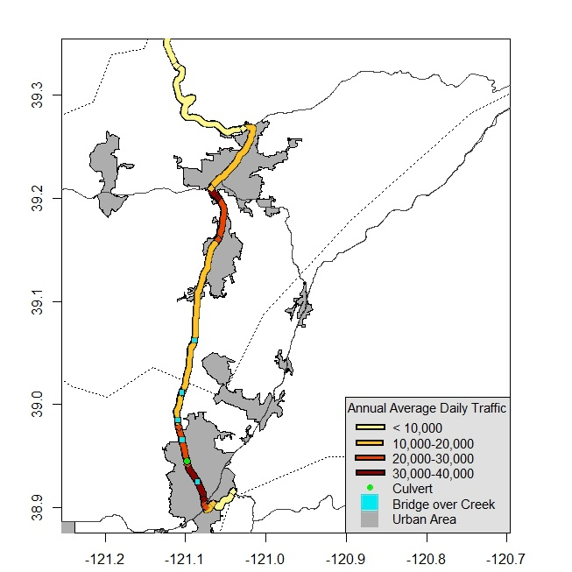

Figure 1. Map of study area and Annual Average Daily Traffic (AADT) volumes along State Route 49.

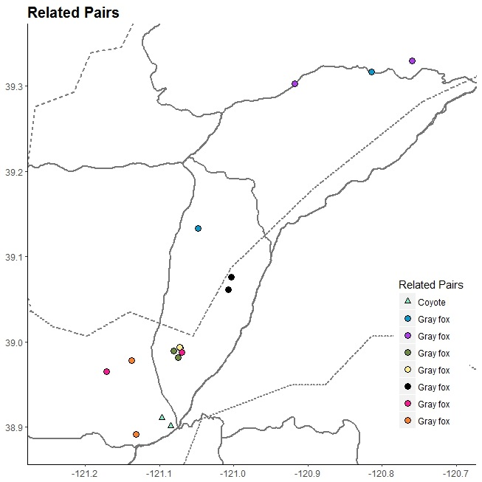

Figure 2. Map of sample locations for related pairs. All samples from related pairs originated from the same side of the highway with the exception of one gray fox pair (pink circle), which was sampled across SR 49 approximately 9 km apart.

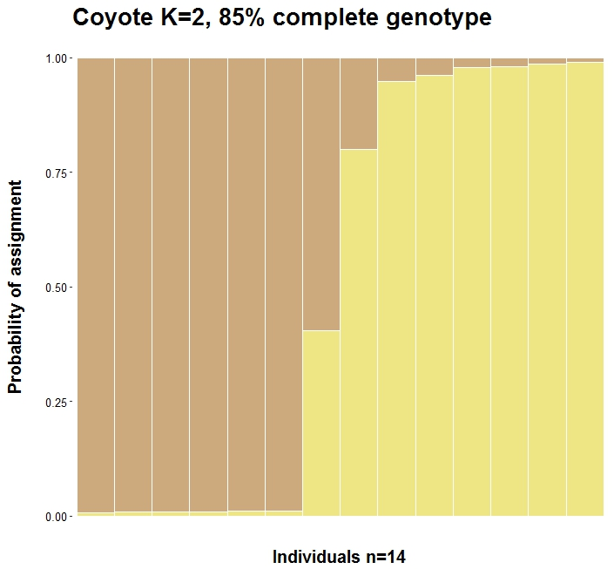

**Proportional Ancestry**

Figure 3. Bar plots depicting individual assignments for coyotes sampled in the study region. Each color corresponds to a genetic cluster identified by STRUCTURE, each bar corresponds to an individual sample, and the proportion of color in each bar depicts an individual’s proportional ancestry in each genetic cluster**.**

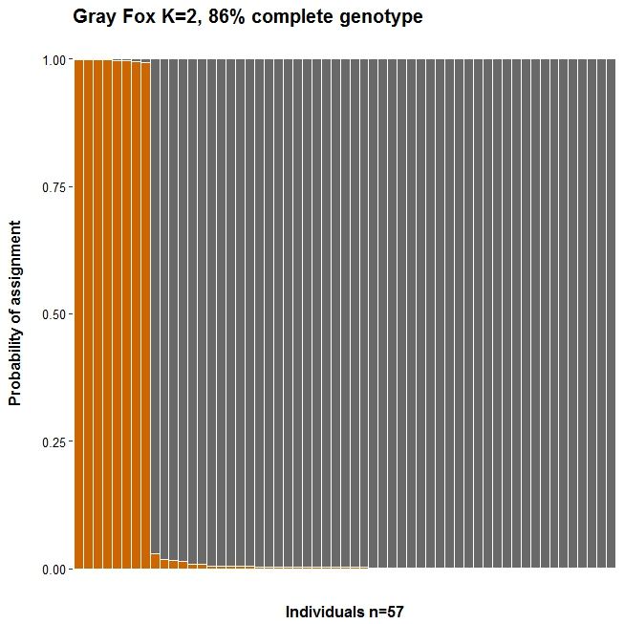

**Proportional** **Ancestry**

Figure 4. Bar plots depicting individual assignments for gray fox sampled in the study region. Each color corresponds to a genetic cluster identified by STRUCTURE, each bar corresponds to an individual sample, and the proportion of color in each bar depicts an individual’s proportional ancestry in each genetic cluster.

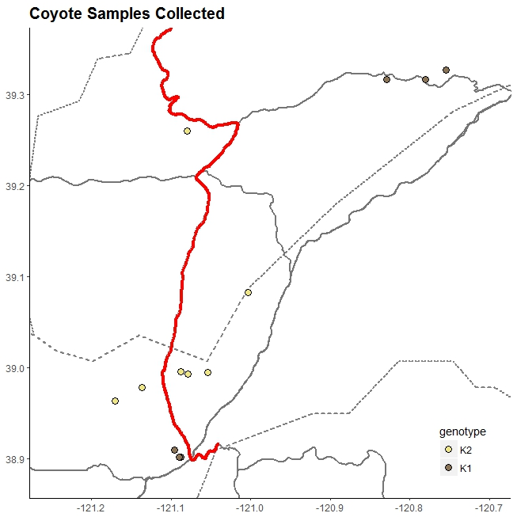

Figure 5. Map of sample collection locations of genotyped coyotes. Colors indicate the genetic cluster they assigned to during STRUCTURE analysis.

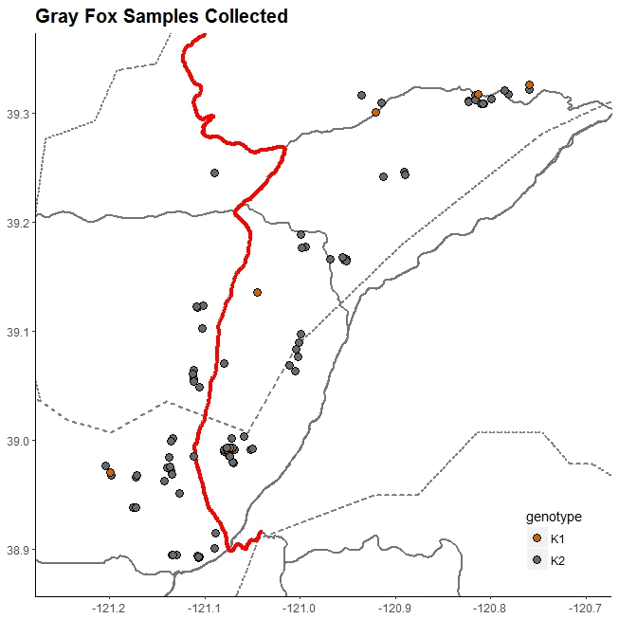

Figure 6. Map of sample collection locations of genotyped gray foxes. Colors indicate the genetic cluster to which they assigned during STRUCTURE analysis.

# References

Alexander SM, Waters NM, Paquet PC (2005) Traffic volume and highway permeability for a mammalian community in the Canadian Rocky Mountains. Can Geogr 49:321–331. doi: 10.1111/j.0008-3658.2005.00099.x

Andrews KM, Gibbons JW (2005) How do Highways Influence Snake Movement? Behavioral Responses to Roads and Vehicles. Copeia 2005:772–782. doi: 10.1643/0045-8511(2005)005[0772:HDHISM]2.0.CO;2

Benítez-López A, Alkemade R, Verweij P a. (2010) The impacts of roads and other infrastructure on mammal and bird populations: A meta-analysis. Biol Conserv 143:1307–1316. doi: 10.1016/j.biocon.2010.02.009

Center for Strategic Economic Research (2014) Placer County Economic and Demographic Profile 2014 Technial report prepared for the County of Placer Office of Economic Development. pp 183.

Charry B, Jones J (2009) Traffic Volume as a Primary Road Characteristic Impacting Wildlife: A Tool for Land Use and Transportation Planning. Proc 2009 Int Conf Ecol Transp 159–205.

Coen A, Schreier A, Shilling F (2015) Pilot Study: Do California highways act as barriers to gene flow for ground-dwelling mammals? White Paper prepared for the National Center for Sustainable Transportation and Caltrans. pp 19.

Coffin AW (2007) From roadkill to road ecology: A review of the ecological effects of roads. J Transp Geogr 15:396–406. doi: 10.1016/j.jtrangeo.2006.11.006

Deyoung RW, Zamorano A, Kleberg C, et al. (2009) Landscape-Genetic Analysis of Population Structure in the Texas Gray Fox Oral Rabies Vaccination Zone. J Wil 73:1292–1299. doi: 10.2193/2008-336

Earl D a., vonHoldt BM (2011) STRUCTURE HARVESTER: a website and program for visualizing STRUCTURE output and implementing the Evanno method. Conserv Genet Resour 4:359–361. doi: 10.1007/s12686-011-9548-7

Epps CW, Keyghobadi N (2015) Landscape genetics in a changing world: Disentangling historical and contemporary influences and inferring change. Mol Ecol 24:6021–6040. doi: 10.1111/mec.13454

Epps CW, Palsbøll PJ, Wehausen JD, et al. (2005) Highways block gene flow and cause a rapid decline in genetic diversity of desert bighorn sheep. Ecol Lett 8:1029–1038. doi: 10.1111/j.1461-0248.2005.00804.x

Evanno G, Regnaut S, Goudet J (2005) Detecting the number of clusters of individuals using the software STRUCTURE: a simulation study. Mol Ecol 14:2611–2620. doi: 10.1111/j.1365-294X.2005.02553.x

Fahrig L, Rytwinski T (2009) Effects of roads on animal abundance: an emperical review and synthesis. Ecol Soc 14:21–41. doi: Artn 21

Farias V, Fuller TK, Suvajot RAMS (2012) Activity and Distribution of Gray Foxes ( Urocyon Cinereoargenteus ) in Southern California. Southwest Nat 57:176–181. doi: 10.1894/0038-4909-57.2.176

Fedriani JM, Fuller TK, Sauvajot RM, York EC (2000) Competition and intraguild predation among three sympatric carnivores. Oecologia 125:258–270. doi: 10.1007/s004420000448

Frankham R (1996) Relationship of genetic variation to population size in wildlife. Conserv Biol 10:1500–1508.

Galpern P, Manseau M, Hettinga P, et al. (2012) Allelematch: An R package for identifying unique multilocus genotypes where genotyping error and missing data may be present. Mol Ecol Resour 12:771–778. doi: 10.1111/j.1755-0998.2012.03137.x

Goslee AS, Urban D, Sarahgosleearsusdagov MSG (2015) Package “ ecodist .”

Holderegger R, Di Giulio M (2010) The genetic effects of roads: A review of empirical evidence. Basic Appl Ecol 11:522–531. doi: 10.1016/j.baae.2010.06.006

Hubisz MJ, Falush D, Stephens M, Pritchard JK (2009) Inferring weak population structure with the assistance of sample group information. Mol Ecol Resour 9:1322–1332. doi: 10.1111/j.1755-0998.2009.02591.x

Jaeger J a G, Bowman J, Brennan J, et al. (2005) Predicting when animal populations are at risk from roads: An interactive model of road avoidance behavior. Ecol Modell 185:329–348. doi: 10.1016/j.ecolmodel.2004.12.015

Jakobsson M, Rosenberg N a (2007) CLUMPP: a cluster matching and permutation program for dealing with label switching and multimodality in analysis of population structure. Bioinformatics 23:1801–1806. doi: 10.1093/bioinformatics/btm233

Kalinowski ST (2005) Hp-Rare 1.0: a Computer Program for Performing Rarefaction on Measures of Allelic Richness. Mol Ecol Notes 5:187–189. doi: 10.1111/j.1471-8286.2004.00845.x

Lande R (1988) Genetics and demography in biological conservation. Science (80- ) 241:1455–1460.

Locke M, Baack E, Toonen R (2007) Quick introduction to STRand Software.

Moore M, Brown S, Sacks B Thirty-one short red fox (Vulpes vulpes) microsatellite markers. Submitted to Mol Ecol Resour.

Neale JCC, Sacks BN (2001) Food habits and space use of gray foxes in relation to sympatric coyotes and bobcats. Can J Zool 79:1794–1800.

Nei M (1972) Genetic distance between populations. Am Nat 106:283–292.

Nei M (1978) Estimation of average heterozygosity and genetic distance from a small number of individuals. Genetics 89:583–590.

Parris KM, Schneider A (2008) Impacts of traffic noise and traffic volume on birds of roadside habitats. Ecol Soc 14:29. doi: 10.1016/j.trd.2005.12.001

Peakall R, Smouse PE (2012) GenAlEx 6.5: genetic analysis in Excel. Population genetic software for teaching and research--an update. Bioinformatics 28:2537–2539. doi: 10.1093/bioinformatics/bts460

Peakall R, Smouse PE (2006) GENALEX 6: genetic analysis in Excel. Population genetic software for teaching and research. Mol Ecol Notes 6:288–295. doi: 10.1111/j.1471-8286.2005.01155.x

Poessel SA, Gese EM, Young JK (2017) Environmental factors influencing the occurrence of coyotes and conflicts in urban areas. Landsc Urban Plan 157:259–269. doi: 10.1016/j.landurbplan.2016.05.022

Pritchard JK, Stephens M, Donnelly P (2000) Inference of population structure using multilocus genotype data. Genetics 155:945–959.

Rice WR (1989) Analyzing tables of statistical tests. Evolution (N Y) 43:223–225.

Riley SPD, Pollinger JP, Sauvajot RM, et al. (2006) A southern California freeway is a physical and social barrier to gene flow in carnivores. Mol Ecol 15:1733–1741. doi: 10.1111/j.1365-294X.2006.02907.x

Riley SPD, Sauvajot RM, Fuller TK, et al. (2003) Effects of Urbanisation and Habitat Fragmentation on Bobcats and Coyotes in Southern California. Conserv Biol 17:566–576.

Sacks BN, Bannasch DL, Chomel BB, Ernest HB (2008) Coyotes demonstrate how habitat specialization by individuals of a generalist species can diversify populations in a heterogeneous ecoregion. Mol Biol Evol 25:1384–1394. doi: 10.1093/molbev/msn082

Sacks BN, Mitchell BR, Williams CL, Ernest HB (2005) Coyote movements and social structure along a cryptic population genetic subdivision. Mol Ecol 14:1241–1249. doi: 10.1111/j.1365-294X.2005.02473.x

Sawaya M a, Kalinowski ST, Clevenger AP (2014) Genetic connectivity for two bear species at wildlife crossing structures in Banff National Park. Proc Biol Sci 281:20131705. doi: 10.1098/rspb.2013.1705

Taylor BD, Goldingay RL (2010) Roads and wildlife: Impacts, mitigation and implications for wildlife management in Australia. Wildl Res 37:320–331. doi: 10.1071/WR09171

Waits LP, Paetkau D (2005) Noninvasive genetic sampling tools for wildlife biologists: a review of applications and recommendations for accurate data collection. J Wildl Manage 69:1419–1433.